Start the program – gui.py

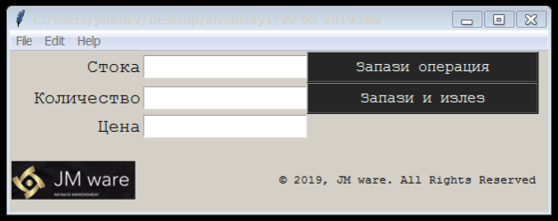

After loading fill in the fields

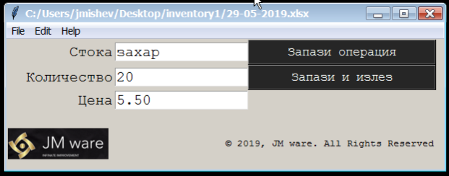

Entry „Стока“ (Good) is not mandatory.

Entries „Количество“ (Quantity) and „Цена“(Price) are mandatory and shall be

floats

In case they are not the program will show the message box:

“ … Have to be valid numbers “

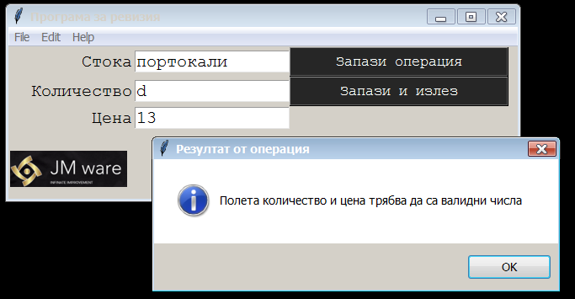

After filling the fields press “ Enter” of select “Запази операция“ ( Save operation)

You can move among the fields with the mouse, arrows and enter.

“Enter” pressed in field „Цена“ (price) – saves current operation

To finish press „Запази и излез“ (Save and exit)

If there are unsaved date on the screen the program will prompt saving them,

If not will save the data in file ( see options below)

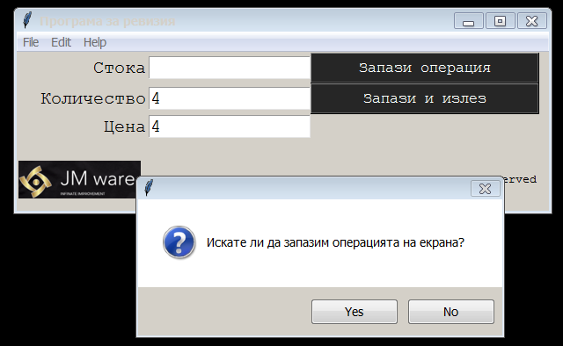

Saving to file :

1. Existing file – operations are added below the previously saved operations

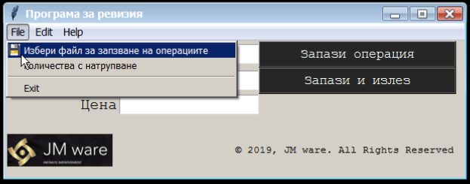

1. To new fail - if there is existing info, will be overwritten